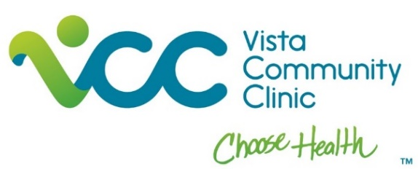
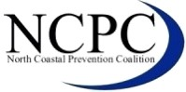
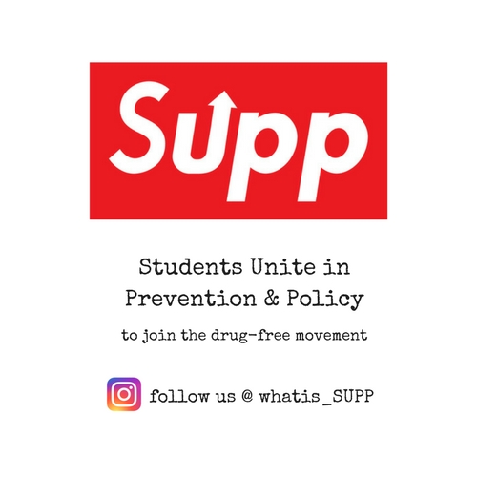

NCPC PARTICIPANT QUESTIONNAIRE
(Visit www.northcoastalpreventioncoalition.org PRIOR to completing to confirm your interest in NCPC programs)

PERSONAL
NAME (LAST, FIRST, MIDDLE)

ADDRESS (NUMBER AND STREET)

CITY, STATE ZIP

EMAIL |  |  |  |  | PHONE
COLLEGE/UNIVERSITY ATTENDING (if applicable) |  |  |  |  | MAJOR COURSE OF STUDY (if applicable)
NUMBER OF HOURS DESIRED  hours total |  |  |  |  | DESIRED START DATE DESIRED COMPLETION DATE  __________________ ____________________
DESIRED SCHEDULE AND AVAILABILITY:
# HRS/WEEK
PLEASE LIST THE DAYS AND TIMES YOU WOULD BE AVAILABLE:
TIME | MONDAY | TUESDAY | WEDNESDAY | THURSDAY |  | FRIDAY
BEGIN
END

PROGRAM INTEREST AND EXPERIENCE
SKILLS YOU MOST WANT TO DEVELOP (Check all that apply – double click box to check if completing in Word)  Research, data analysis and reports  Public speaking  Website design and/or maintenance  Educational materials development  Film/video production and/or graphic design  Community outreach  Community needs assessment  Event planning and coordination  Grant development | PREVIOUS EXPERIENCE (Check all that apply - double click box to check if completing in Word)  Microsoft Word  Microsoft Excel  Microsoft PowerPoint  Microsoft Publisher  Film/Video production  Graphic design  Website design and/or maintenance  Public speaking  Bilingual (English/Spanish)  Tutoring/working with youth | SOCIAL MEDIA EXPERIENCE (Check all that apply - double click box to check if completing in Word)  Facebook  Instagram  Twitter  Other

PARTICIPANT GOALS
NCPC’S MISSION IS TO REDUCE THE HARM OF ALCOHOL, TOBACCO, MARIJJUANA AND OTHER DRUGS IN THE CITIES OF CARLSBAD, OCEANSIDE AND VISTA THROUGH COMMUNITY ACTION, EDUCATION, SUPPORT AND COLLABORATION.
PLEASE DESCRIBE WHY YOU WOULD LIKE TO PARTICIPATE WITH NCPC PROGRAMS:

WHAT SKILLS DO YOU HAVE TO CONTRIBUTE TO NCPC PROGRAMS?

WHAT SKILLS AND/OR EXPERIENCES DO YOU HOPE TO OBTAIN BY PARTICIPATING WITH NCPC PROGRAMS?

.
DO YOU HAVE ANY PROJECTS IN MIND THAT YOU WOULD LIKE TO BE ABLE TO ACCOMPLISH WITH NCPC PROGRAMS?

DO YOU HAVE ANY RELATIVES CURRENTLY EMPLOYED AT VISTA COMMUNITY CLINIC? IF YES, INDICATE NAME, RELATIONSHIP, AND DEPARTMENT.

Thank you for your interest in the North Coastal Prevention Coalition
Please submit this completed form and email to info@northcoastalpreventioncoalition.org
If you do not receive a response within 5 working days, please contact:
Erica Leary, Program Manager – eleary@vcc.org OR
Debbie Obregon, Project Assistant – dobregon@vcc.org

